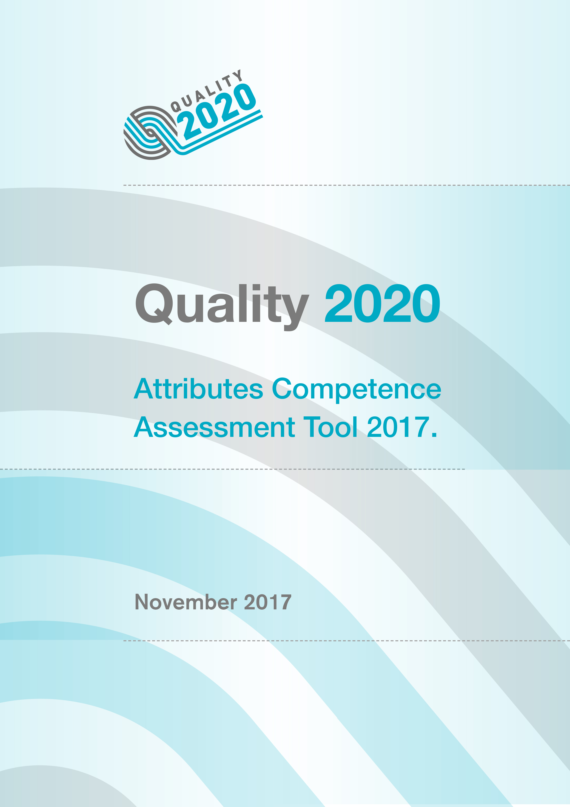

Quality 2020 Attributes Competence Assessment Tool
When you are undertaking a self-assessment, the Quality 2020 Attributes Competence Assessment Tool (below) can help you identify the knowledge, skills and attitudes required for your role. You will be expected to discuss your self-assessment with your line manager, as part of your annual appraisal and/or personal development plan, in order to agree an action plan addressing your identified learning and development needs. If you are in training within Health and Social Care, you can discuss the results of your self-assessment with your mentor or supervisor and agree your learning and development needs.

Assessing yourself

You should use the following rating scale to assess your learning and development needs against each of the attribute statements within your level:

Rating Scale: LD I need a lot of development
SD I need some development
WD I feel I am well developed

It generally takes about 15 minutes to assess yourself against the attribute statements. When you have finished, review the number of LDs, SDs, and WDs. You can then plan, with your line manager, the learning and development activities which are relevant to your role.

Practice Tips

Before starting your assessment, you may find it helpful to discuss the attribute statements with one of your peers. You can also test your self-assessment with your line manager. Be honest with yourself when thinking about your role and your learning and development needs and rate them realistically.

The Quality 2020 Attributes Framework and Competence Assessment Tool can also enable you to focus on areas for career development and, where relevant, support your preparation for job interviews. They can also be used in conjunction with other frameworks and competencies relevant to your role.

Strengthening foundations for improvement

This component of the Quality 2020 Attributes Framework identifies the core foundation knowledge, skills and attitudes required to deliver safe, effective, person-centred care (or person-centred services) related to your role. It is an essential requirement for everyone, either working or in training in health and social care, to be competent in all attributes at this level.

Who for:
This applies to all staff who work, or who are in training, in health and social care.

Rating Scale: LD I need a lot of development
SD I need some development
WD I feel I am well developed
(Only select one option)
Attributes | LD | SD | WD
- I understand why and how we put patients/service users at the centre of everything we do | ☐ | ☐ | ☐
- I understand what contributes to the safety of patients/service users and work with my colleagues to identify problems and help reduce risks | ☐ | ☐ | ☐
- I understand what is meant by quality improvement and collect information in my area to aid improvement in patient/service use care and services | ☐ | ☐ | ☐
- I understand how I can play my part in improving care and services for patients/service users | ☐ | ☐ | ☐
- I take part in activities to improve the way I do my job | ☐ | ☐ | ☐
- I understand the benefits of using small steps to improve care and services | ☐ | ☐ | ☐
- I understand the benefits of developing myself in order to care for others | ☐ | ☐ | ☐
- I keep my knowledge and skills up to date | ☐ | ☐ | ☐
- I develop my skills in improvement methodology | ☐ | ☐ | ☐
- I work with my colleagues as an effective team member | ☐ | ☐ | ☐
- I listen to patients/service users and their carers/families and share their comments with colleagues to help improve care/services | ☐ | ☐ | ☐
- I understand my responsibility to speak up if something goes wrong and I know how to do this | ☐ | ☐ | ☐
Delivering improvement

This component of the Quality 2020 Attributes Framework identifies the knowledge, skills and attitudes required to make small-step-change in a service which will lead to quality improvement.

Who for:
This applies to staff and those in training, who can lead small-step-change(s), with support, in their service.

Rating Scale: LD I need a lot of development
SD I need some development
WD I feel I am well developed
Attributes | LD | SD | WD
- I understand how the culture in my workplace influences the quality and safety of care and services | ☐ | ☐ | ☐
- I recognise my responsibility to question the way we work in order to improve care and services | ☐ | ☐ | ☐
- I am able to work with a team to achieve small-step-change | ☐ | ☐ | ☐
- I can explain and use PDSA cycles to make small-step-change to care and services. | ☐ | ☐ | ☐
- I can identify where teamwork could be more effective and I work with others to improve team performance | ☐ | ☐ | ☐
- I work to involve patients/service users and their carers/families in planning care and in quality improvement activities | ☐ | ☐ | ☐
(Only select one option)

Driving improvement

This component of the Quality 2020 Attributes Framework identifies the knowledge, skills and attitudes required to lead quality improvement in the workplace.

Who for:
This applies to staff who lead team(s) or service(s) within their organisation.

Rating Scale: LD I need a lot of development
SD I need some development
WD I feel I am well developed
(Only select one option)
Attributes | LD | SD | WD
- I communicate effectively with diverse audiences | ☐ | ☐ | ☐
- I mentor and teach others about improvement methodology | ☐ | ☐ | ☐
- I understand, use and present data to improve care and services | ☐ | ☐ | ☐
- I influence, negotiate and lead improvements in care and services | ☐ | ☐ | ☐
- I strive to motivate and energise my colleagues | ☐ | ☐ | ☐
- I demonstrate resilience in order to lead improvements in care and services | ☐ | ☐ | ☐
- I facilitate and lead teams to improve the quality and safety of care and services | ☐ | ☐ | ☐
- I encourage, promote and support a learning culture in my workplace | ☐ | ☐ | ☐
- I listen to the voices of patients/service users and their carers/families using their input to inform quality improvement activities | ☐ | ☐ | ☐
- I use systems such as governance, quality assurance and measurement for improvement to identify for myself and team members areas for development | ☐ | ☐ | ☐

Directing improvement
This component of the Quality 2020 Attributes Framework identifies the knowledge, skills and attitudes required to advise on and lead quality improvement across service boundaries.

Who for:
This applies to staff charged with leading quality improvement across their organisation and/across the Health and Social Care system. in Northern Ireland. These individuals are also responsible for ensuring that quality improvement is imbedded in the day-to-day work of the organisation.

Rating Scale: LD I need a lot of development
Attributes | LD | SD | WD
- I lead improvement in care and services, aligning priorities and removing barriers | ☐ | ☐ | ☐
- I encourage, promote and support a learning culture in and/or across organisations, learning from engagement with patients/service users and their carers/families | ☐ | ☐ | ☐
- I direct the implementation and spread of improvement methodology across service boundaries | ☐ | ☐ | ☐
- I advise/have access to expert advice on the development of improvement measures and understand variation in data, using relevant tools where appropriate | ☐ | ☐ | ☐
- I monitor the quality and safety of care, understanding that measurement is for learning, not judgement | ☐ | ☐ | ☐
- I provide/have access to expert advice and maintain an oversight of the progress of improvement | ☐ | ☐ | ☐
- I use evidence-based tools, or accepted guidance, to ensure that appropriate resources are used in the organisation | ☐ | ☐ | ☐
- I direct the improvement work across the organisation and respond directly, openly and rapidly to safety alerts, early warning systems and complaints from patients/service users and staff | ☐ | ☐ | ☐
- I promote transparency across the organisation | ☐ | ☐ | ☐
- I provide high-level support to a multi-organisational collaborative network, in which teams can learn from, and teach, each other | ☐ | ☐ | ☐
- I pay attention to my own learning so that I enhance the way in which I direct improvement within my organisation | ☐ | ☐ | ☐
SD I need some development
WD I feel I am well developed
(Only select one option)




